FOR IMMEDIATE RELEASE

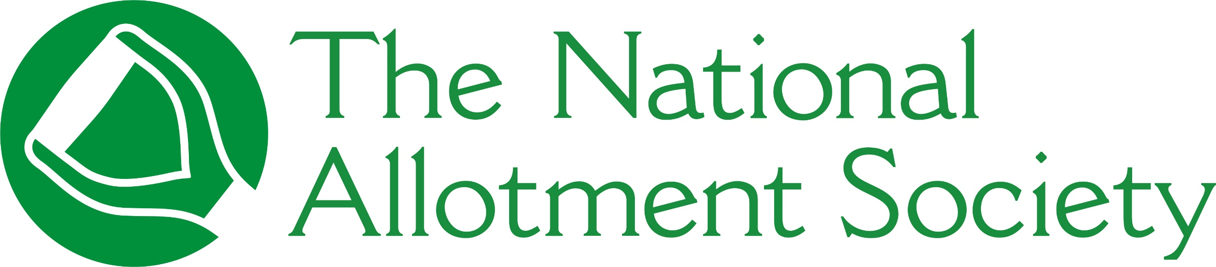

PRESS RELEASE

[DATE]

National Allotment Society launches nationwide drive to preserve UK plots

The National Allotment Society (NAS), the UK’s leading representative body for allotment holders, has launched a nationwide membership drive, inviting plot holders, gardeners, and community groups to help protect, promote and preserve allotments for future generations.
With waiting lists for plots at historic highs, the call for new members aims to ensure NAS can continue to defend green spaces, support local growers and empower communities. Membership is open to individual plot holders, schools, landowners and local allotment associations.
The society provides its network of 132,000 members with the essential tools, community support and legal protections needed to thrive on the plot. Expert advice and guidance on a range of issues include site management, environmental concerns, tenancy agreements and fundraising is also provided.
Those signing up for membership will benefit from:

- Allotmenteer’s liability insurance to cover plot activities
- Free initial legal advice for allotment-related issues
- Discounted NAS insurance
- Retail discounts on a range of gardening products
- A discount on King's Seeds, allowing members to buy high-quality fruit, flower, and vegetable seeds at reduced prices
- Subscription to The Allotment Gardener magazine, available in both print and digital formats

For local councils and allotment associations, NAS also provides site management frameworks and template legal documents.

Sonia Gallagher, National Secretary and General Manager at NAS, said: “As a membership organisation representing over 132,000 members, we are proud to be more than just a society – we are a movement.
“Allotments are a valuable part of our UK heritage and have such a positive impact on health and community wellbeing. That’s why it’s vital that they continue to be preserved for future generations.”
For more information about the National Allotment Society and how to become a member, visit https://thenas.org.uk/joinus

[ENDS]

Please direct any press enquiries to Emma Speirs on 01536 682800 or email emma.speirs@ballyhoo-pr.co.uk

NOTES TO EDITORS

Plot holders, gardeners, and community groups are being invited to help protect, promote and preserve allotments for future generations.

About the National Allotment Society
With over 132,000 members, The National Allotment Society (NAS) is the leading representative body for UK allotment holders. Its mission is to protect, promote and preserve allotments for future generations.

NAS works with allotment sites, associations, councils and individual plot holders to provide advice and guidance on a range of issues including site management, environmental concerns, tenancy agreements and fundraising.

For more information, go to https://thenas.org.uk/ or follow NAS on Facebook and Instagram

